Lesson - 1 Intro to Digital Marketing

Marketing: The process of promoting and selling products or services to customers.

Digital Marketing: Promoting and selling products or services using digital channels like social media, websites, search engines, and email. The goal is not simply to be online but it is to reach right people , build trust and make them to take action that is buy product or use that service. Ex : Google Search , SEO , Google Ads
The main difference between both is not just offline vs online
Digital marketing gives us much better opportunities to:
- Target specific audiences
- Measure results
- Track customer actions
- Test different messages
- Adjust campaigns
- See where customers came from

Major areas of digital marketing
SEO - Getting organic visibility on search engines.
Google Ads - Paying for relevant search/ad placements.
Social Media Marketing - Using platforms such as Instagram and Facebook.
Content Marketing- Creating useful content that attracts and educates people.
Email Marketing- Communicating with prospects/customers through email.
Affiliate Marketing- Promoting products/services for commissions.
Local SEO - Helping local customers discover a physical business.
Analytics - Measuring what happened and why.
Organic vs Paid Marketing
Organic : we don’t pay for advertising here instead we use the time , skill and resources to reach people
Ex : SEO , Organic Instagram posts , Organic YouTube videos , Google Business Profile visibility
Paid : as in the name we need to pay the advertising platform to reach people
Ex : google , FB , insta , youtube ads
Lead : A lead is a person who has shown interest and could potentially become a customer. A person simply seeing your Instagram post isn't necessarily a lead.
Conversion : valuable action that you want the customer to take.
Understanding the target audience is major part in marketing
Marketing Channel : A channel is a way through which you reach customers.
Channel | Purpose
Google Search | Capture people actively searching
Google Maps | Help local customers find you
Website | Explain products/services
Instagram | Awareness & engagement
Facebook | Local reach
Google Ads | Paid search traffic
Meta Ads | Paid social reach
Email | Retention
WhatsApp | Enquiries/conversations
Marketing Objective : is what you're trying to achieve.
KPI = Key Performance Indicator - These are measurements that tell us whether our marketing is working.

Vanity Metrics - A vanity metric looks impressive but may not mean much for the business. Attention is not the same as business results.
Example :
Goal: More store visits
Customer: Local homeowners/electricians/contractors
Channel: Google Search + Google Maps
Message: Relevant electrical/hardware products available locally
Action: Call / Directions / Visit
Measurement: Calls, enquiries, directions, visits/sales where measurable
Optimization: Improve keywords, ads, website, profile, targeting, etc.

Lesson – 2 Keyword Research

A keyword is a search phrase that represents what someone is searching for online.
Search query = what the user actually searches
Keyword = what the marketer uses to organize/target that search intent
Keyword research : Finding, analyzing, and organizing the words and phrases that potential customers use when searching for products, services, information, or businesses online.
Seed keyword: A seed keyword is a broad starting idea.
Ex :
- electrical
- hardware
- paints
- plumbing
- electrical shop
- hardware shop
- electrical products
- plumbing materials
These aren't necessarily the final keywords. They're the starting seeds from which we discover hundreds of more specific searches.
Now lets grow one of the keys that is , electrical shop we can further have ,
• electrical shop near me
• electrical shop in Warangal
• electrical shop in Hanamkonda
• electrical hardware shop
• electrical shop near Balasamudram
• electrical supplies shop
• electrical material shop
Short-tail keywords - Usually broad and relatively short.
Examples: electrical, hardware

Long-tail keywords - Usually more specific phrases.
Examples : electrical shop near me , electrical hardware shop in Hanamkonda
Search Intent : opinion or the need of user behind that search
Types : informational , commercial( resrach before taking decision) , transactional ( buying ) , local intent ( need locations )
Don't just look at the keyword. Understand the intent behind it.

------- Based on Google ads platform -----
Search Volume : Search volume is an estimate of how many searches a keyword receives over a period.
For example, Keyword Planner may show: 1K–10K
Competition : primarily refers to advertiser competition.

Search volume → demand estimate
Ads competition → advertiser competition
Bid/CPC estimate → advertising cost signal

Don't Choose Keywords Just Because Volume Is High
High volume + low relevance = poor keyword
For example in our case , computer hardware generally has high volume but it is not relevant to our business
Keyword Relevance – high , medium and low

Primary keyword - The main search theme for a page.
Example: electrical shop in Hanamkonda

Secondary keywords - Closely related phrases.
For example:
- electrical hardware shop
- electrical materials shop
- electrical products
- electrical store
- electrical items
They support the main topic.

We can research keywords and map them to the most appropriate page.This is called:
Keyword mapping

TOOLS FOR KEYWORD RESEARCH –
Google Keyword Planner
Google Search
Google Trends
Google Search Console ( once website gets traffic)
Google Keyword Autocomplete ( once website gets traffic)
Proffesional tools ---
Ahrefs
Semrush
Moz
Ubersuggest

Question Tools
AnswerThePublic
AlsoAsked
KeywordTool.io
Others –
Keyword surfer (browser extension )
KW FINDER
Serpstat
AI tools ---
Chatgpt , Gemini , claude

Got using google auto complete ---

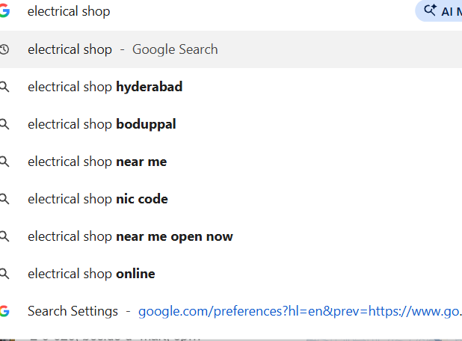

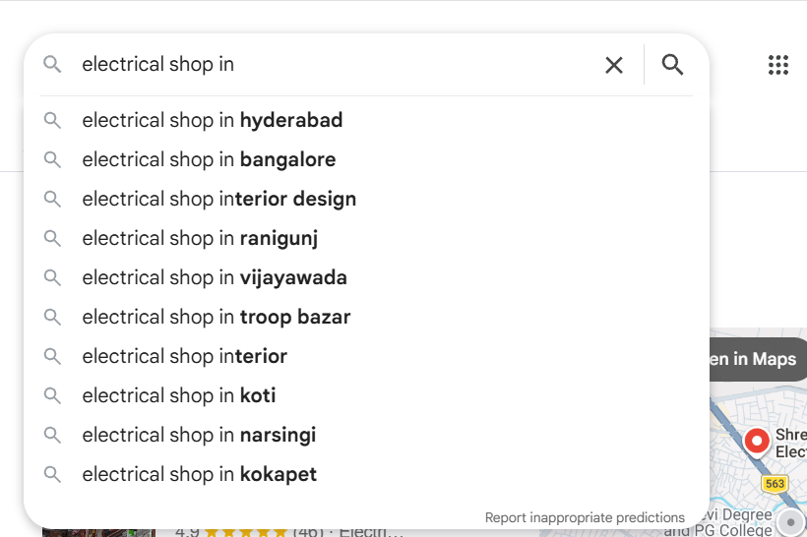

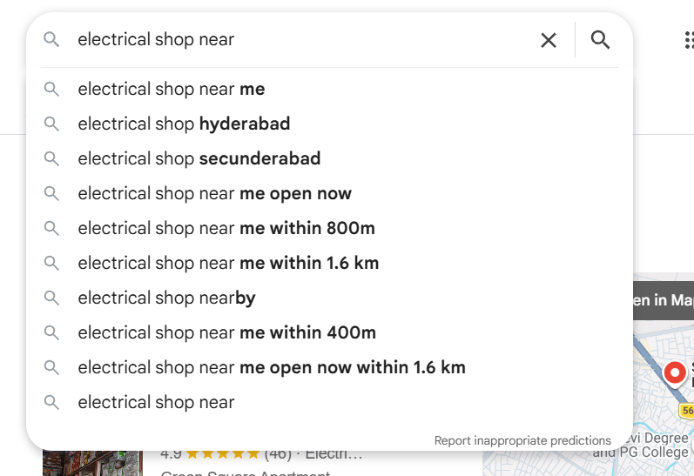

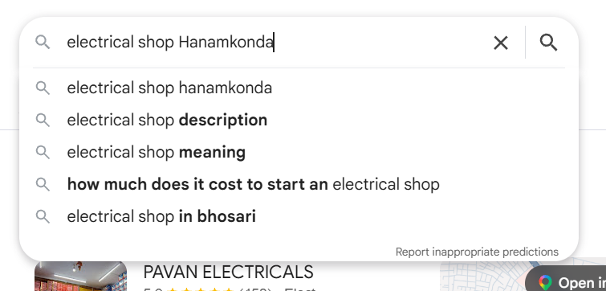

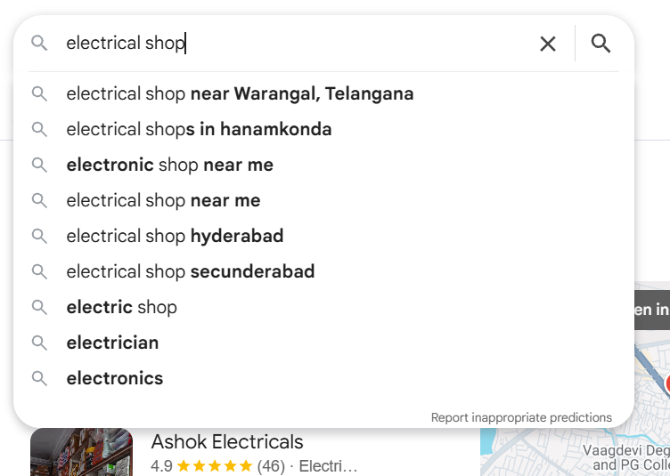

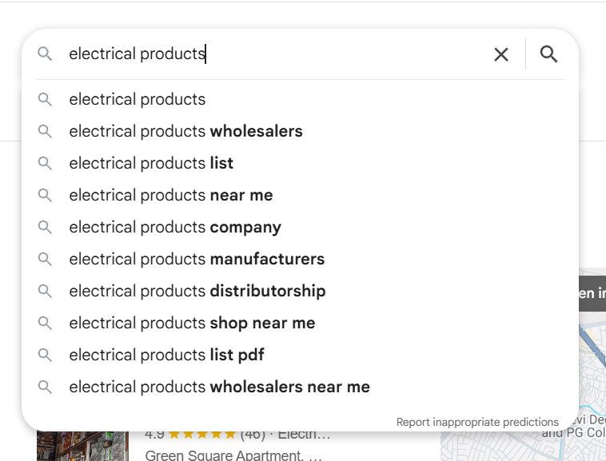

Using aref -----
electrical shop near warangal, telangana
electrical shops near me
electrical shops in hanamkonda
electrical shop near me open now
electronic shop near me
Google trends ---

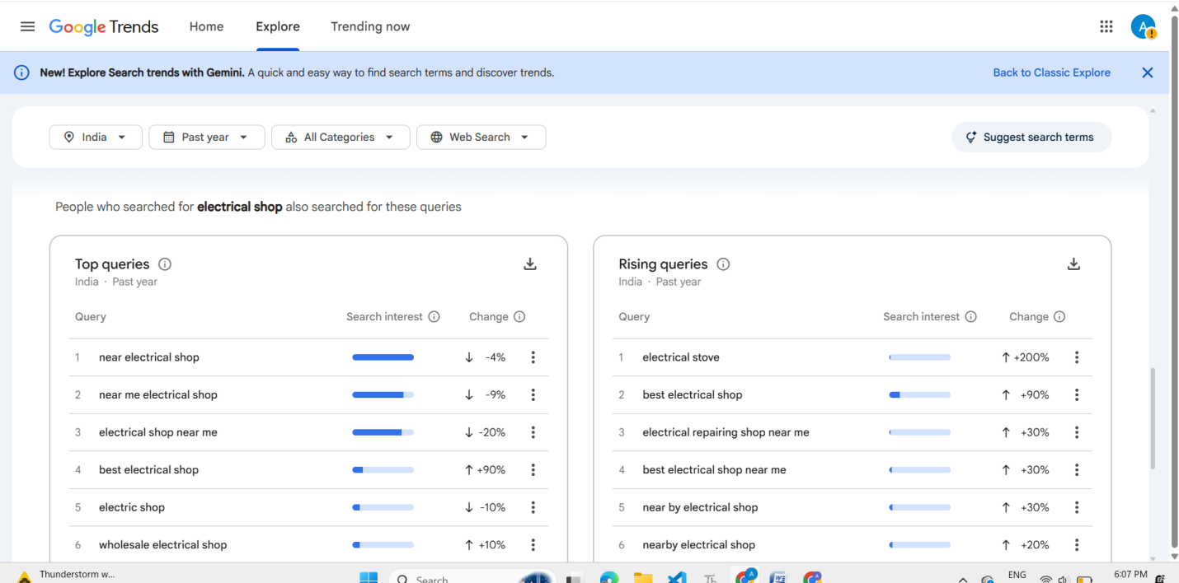

Examples of Top Keywords :
electrical shop
electrical shop near me
electrical shops near me
electrical shop in Hanamkonda
electrical shop in Warangal
electrical shop near Balasamudram
electrical store near me
best electrical shop near me
electrical shop near me open now
electrical products
electrical materials
electrical hardware shop
hardware shop
hardware shop near me
paint shop
paint shop near me
plumbing materials
plumbing materials near me
plumbing shop near me
electrician near me

Google ads ---

